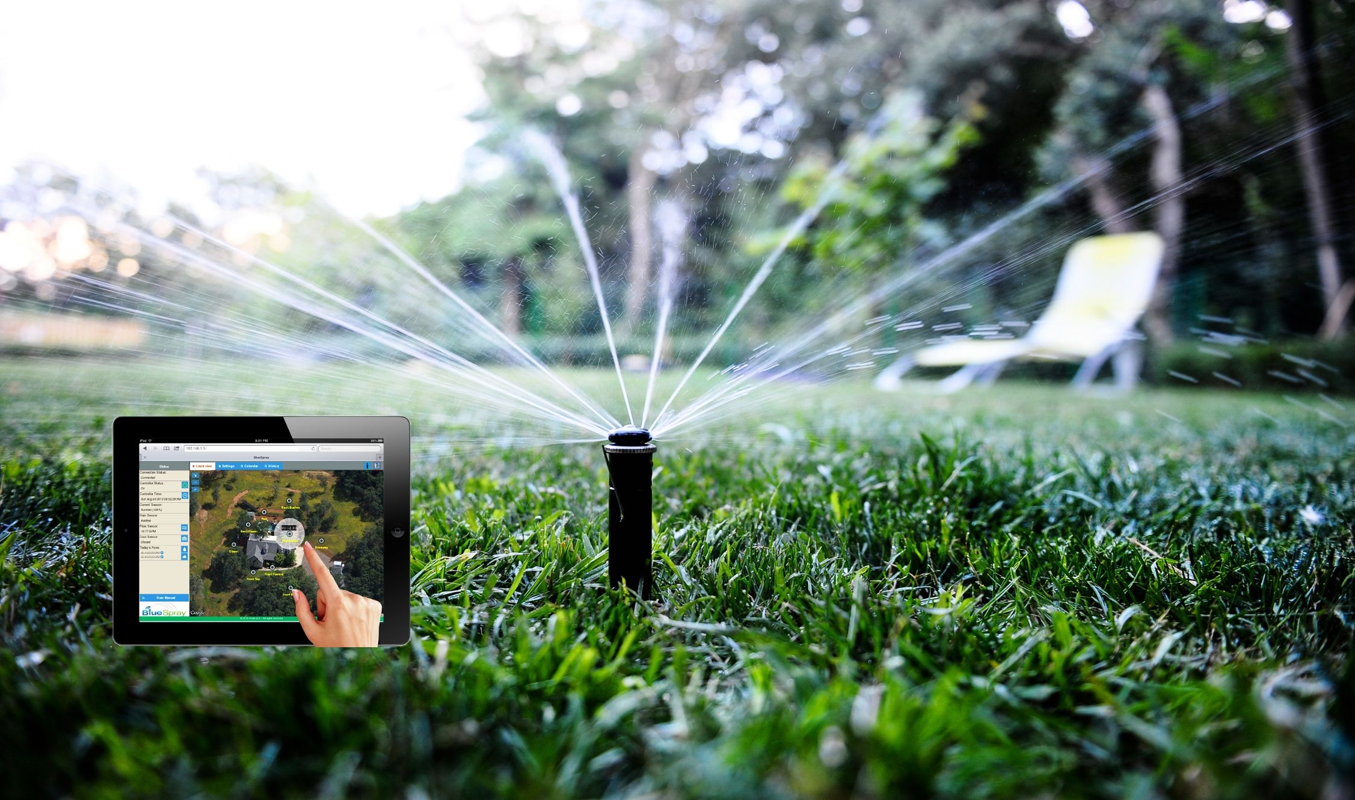
Smart Irrigation System Project Using ESP8266 NodeMCU

Referred to::
Dr. [Ra'ed Al-Khatib ]


Sent by :[Tasneem Alomari , Rama Almomani ,Raghad Allahham ,Firas Almomani]

Date:
[6/1/2025]


Introduction:
In today’s rapidly evolving technological landscape, the use of smart irrigation systems has become essential for water conservation and improving agricultural efficiency. This project aims to design and implement a smart irrigation system based on the NodeMCU ESP8266 microcontroller. The system utilizes multiple sensors to measure soil moisture, temperature, and water level, in addition to controlling a water pump.

This system helps reduce water wastage and enhances crop quality by providing optimal conditions for plant growth. It also offers remote control and monitoring capabilities via an API interface, facilitating efficient and intelligent irrigation management.

Components:

*The project consists of the following main components:

NodeMCU ESP8266 :Acts as the main microcontroller, handling sensor data and controlling the water pump.
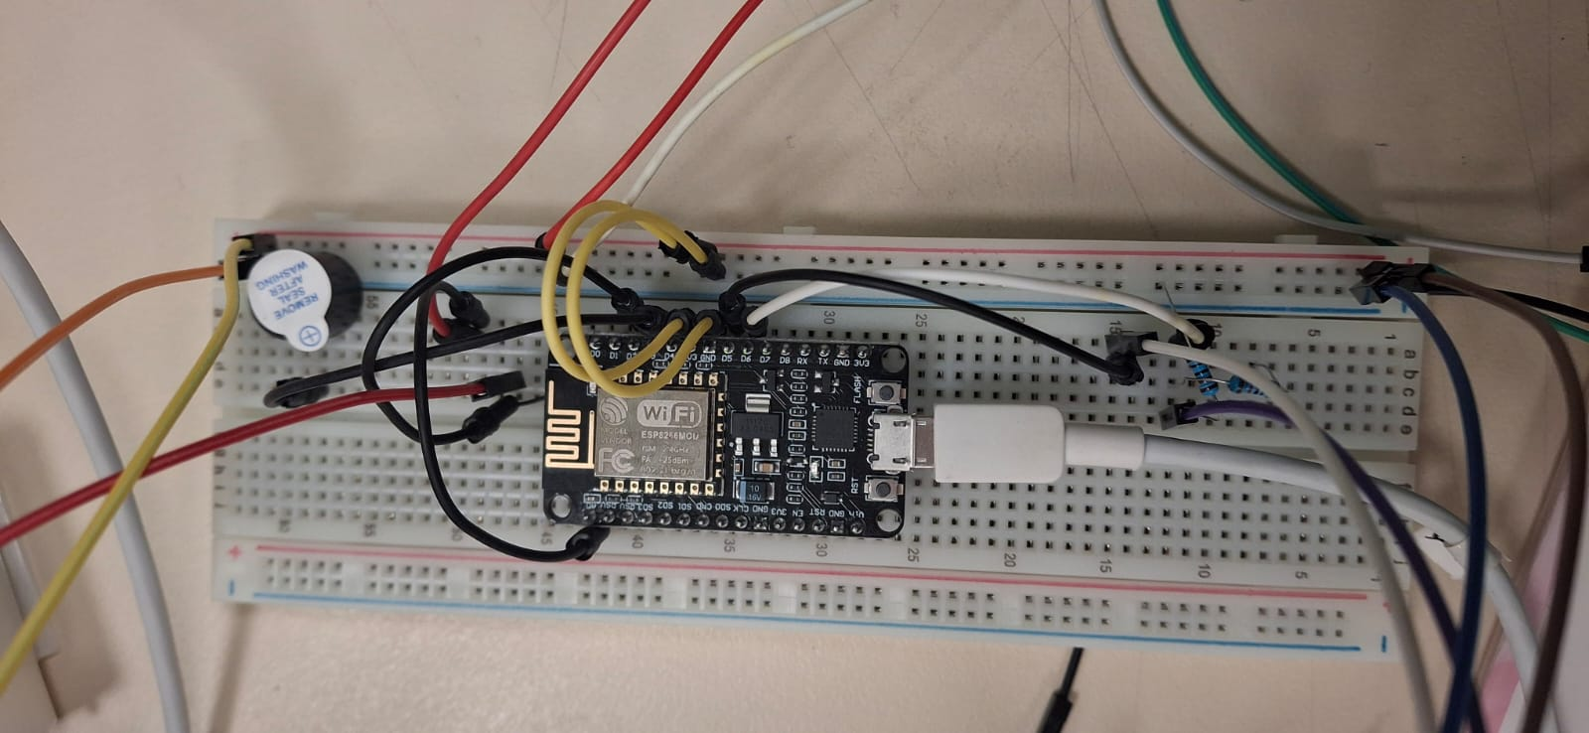

Capacitive Soil Moisture Sensor: Measures the moisture level in the soil to determine irrigation needs.

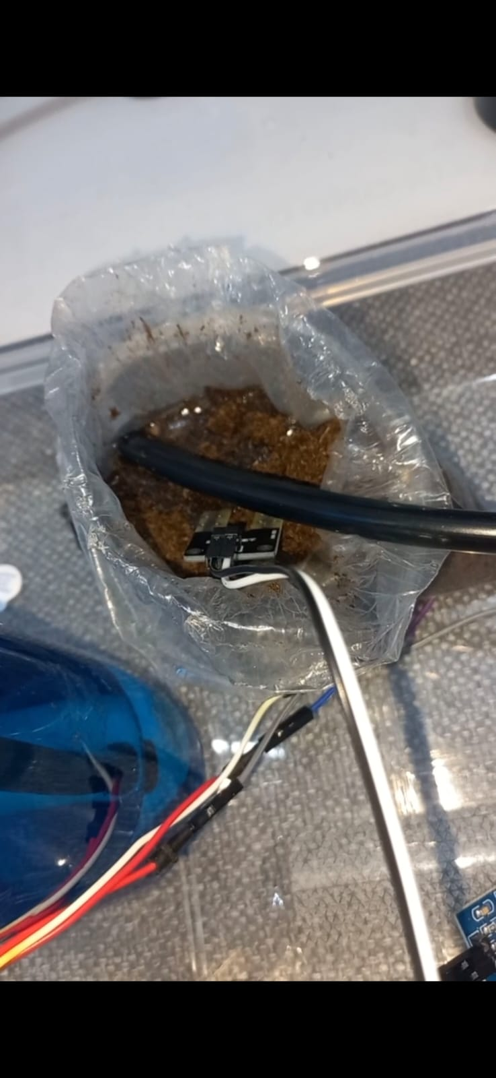

DHT11 Temperature and Humidity Sensor: Provides ambient temperature and humidity data to optimize irrigation conditions.
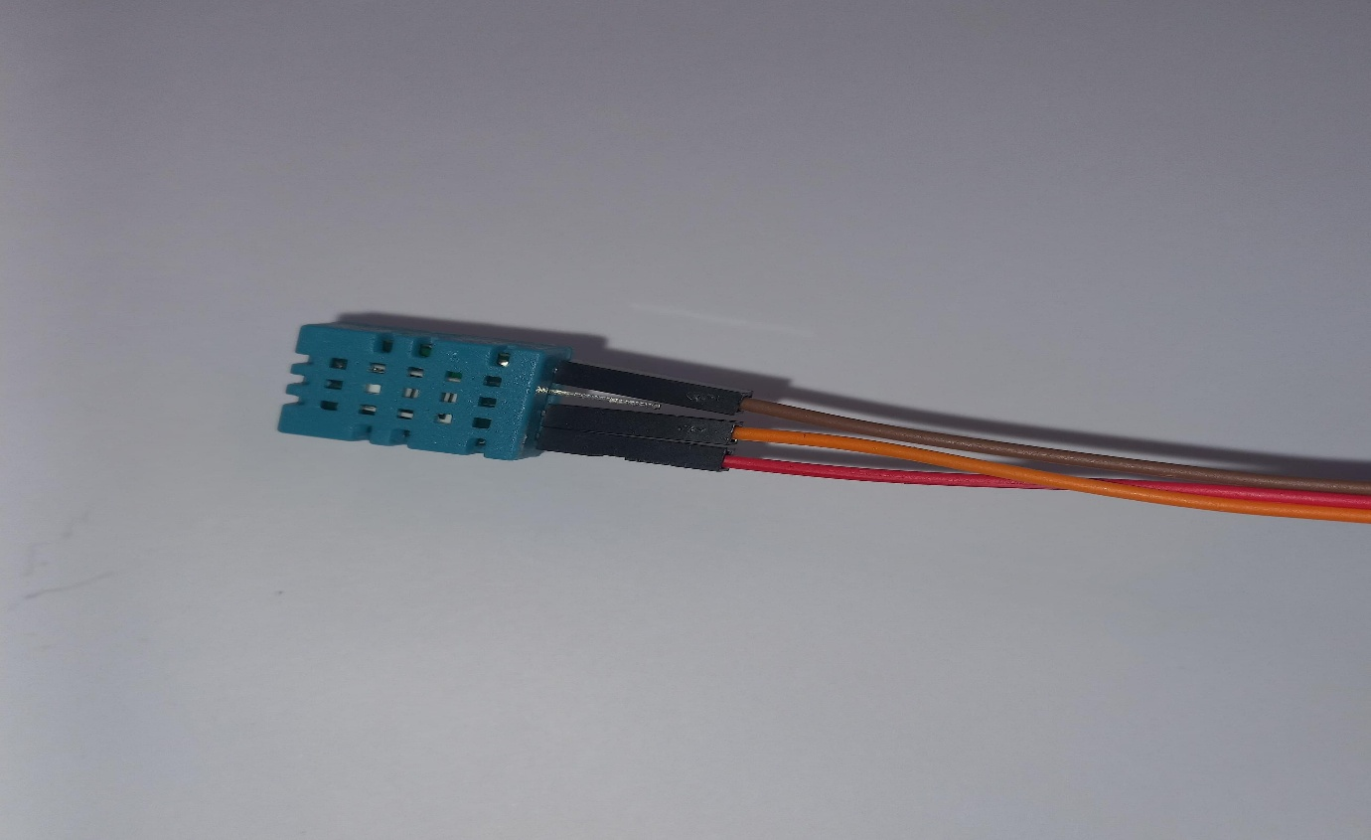

HC-SR04 Ultrasonic Distance Sensor: Measures the water level inside the storage tank to prevent dry running of the pump.

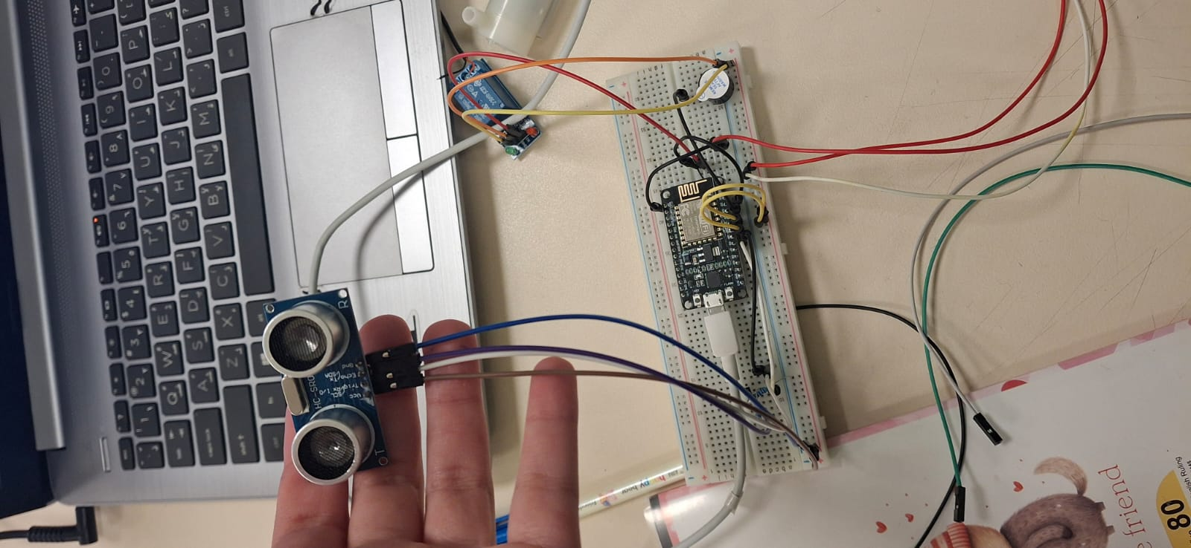
5V Relay Module: Controls the power supply to the water pump based on the sensor readings.

A water pump :is a device used to move water from one place to another. In a smart irrigation system, it automatically pumps water to the plants based on soil moisture data. Its operation is controlled electronically through a microcontroller and activated via a relay.
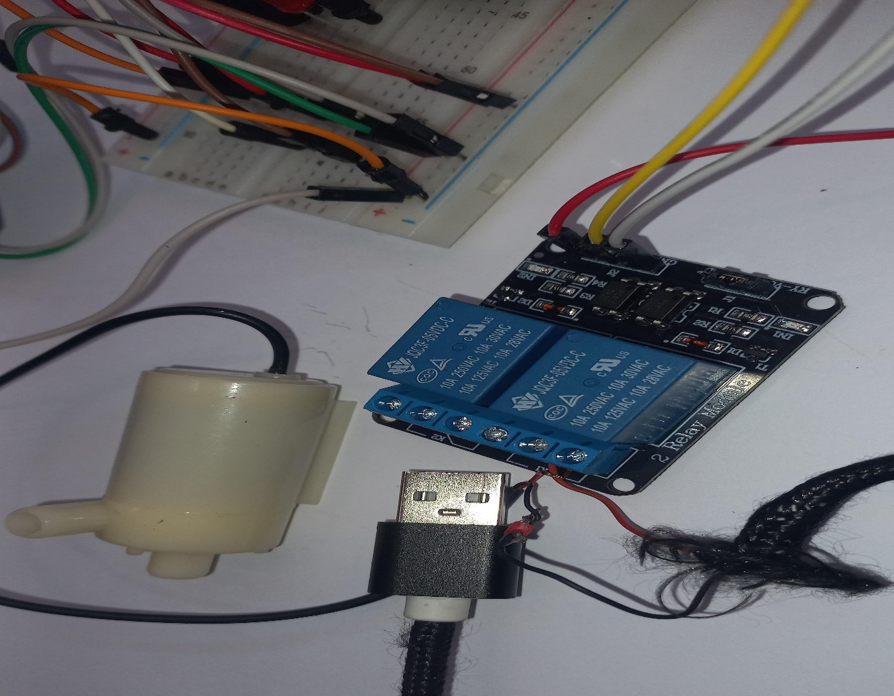

I2C LCD 1602 Display: Displays real-time sensor readings and system status.

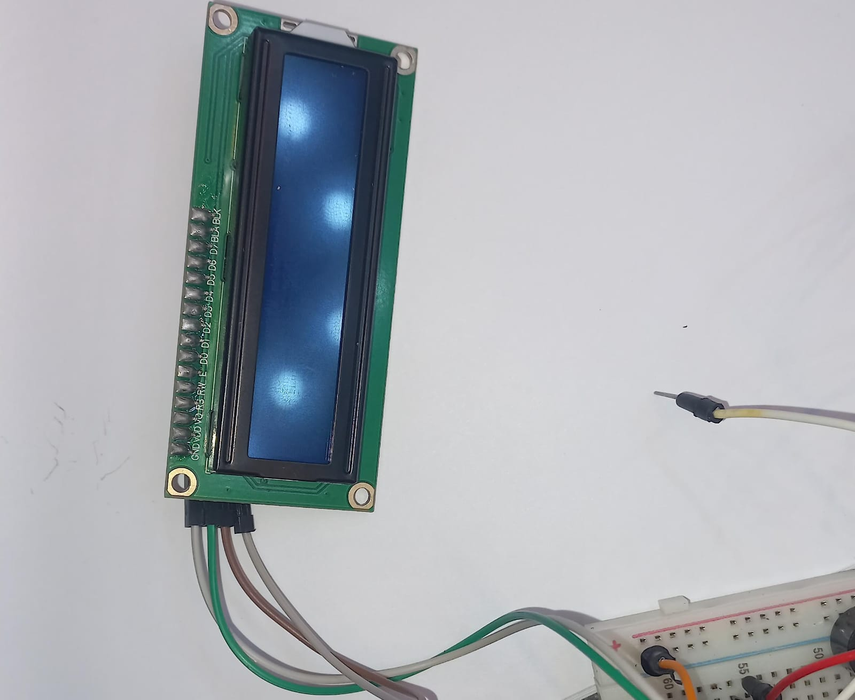

Supplies: NodeMCU is powered via USB or VIN pin, while the pump and relay use an external 12V power source.

System Description and Functions 🚰🌱
The smart irrigation system collects data from multiple sensors including:
- Soil Moisture 🌡️
- Temperature 🌞
- Humidity 💧
- Water Level 📏
Based on predefined threshold values, the system decides automatically when to activate the water pump.
The microcontroller continuously processes sensor inputs and:
- Triggers the relay to turn the pump ON or OFF accordingly 🔄
- Updates the LCD screen to provide real-time feedback on sensor readings and pump status 📟

Additionally, the system offers remote monitoring and control through a REST API 🌐, allowing users to:
- Check sensor data from anywhere 📊
- Manually control the pump remotely 🕹️

Wiring and Circuit Connections 🔌🧠
The system wiring is centered around the NodeMCU ESP8266 microcontroller, and involves connecting multiple components as follows:

🔸 Soil Moisture Sensor 🌾
- VCC → 3.3V
- GND → GND
- AOUT → A0 (Analog Input) on NodeMCU

🔸 DHT11 Temperature & Humidity Sensor 🌡️💧
- VCC → 3.3V
- GND → GND
- DATA → D4 (Digital Pin)

🔸 HC-SR04 Ultrasonic Sensor 📏🔊
- TRIG → D6
- ECHO → D7 (with voltage divider to step down from 5V to 3.3V)
- ⚠️ Use a 2.2kΩ and 1kΩ resistor voltage divider for echo pin

🔸 Relay Module 🔁⚡
- IN → D5 (Controls the water pump)
- VCC → External 5V
- GND → GND
- COM → 12V+ from external power supply
- NO → Pump Positive Terminal

🔸 I2C LCD Display (1602) 🖥️
- SDA → D2 (GPIO4)
- SCL → D1 (GPIO5)
- VCC → 5V External
- GND → GND

⚙️ Power and Protection Tips
- 🟢 All components share a common ground
- 🔌 NodeMCU can be powered by USB or 5V VIN pin
- 🔁 Use a 100μF capacitor across relay’s VCC and GND for stability
- 🛡️ Add a flyback diode across pump terminals to protect against voltage spikes

System Architecture Diagram 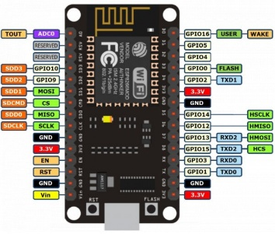
The smart irrigation system is designed around a modular architecture where both hardware and software components interact to ensure optimal functionality.
- Sensor Modules (Soil Moisture, DHT11, and Ultrasonic) provide environmental data.
- The ESP8266 NodeMCU processes these sensor inputs and applies predefined logic to control the water pump.
- A Relay Module serves as an electronic switch that controls the pump's operation.
- The I2C LCD Display shows real-time sensor data and pump status for local monitoring.
- A REST API interface allows remote access and control, enabling users to manually operate the system or view telemetry.
Key Communication Paths:
- Sensors ➝ NodeMCU (Analog/Digital Readings)
- NodeMCU ➝ Relay Module ➝ Water Pump (Control Signal)
- NodeMCU ➝ LCD Display (Data Output)
- NodeMCU ⬄ REST API (HTTP Requests)

Software Implementation 💻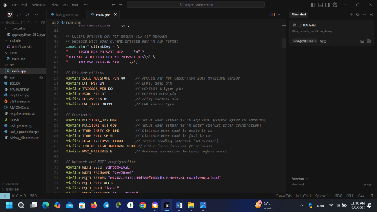
The system is programmed using python in the Arduino IDE, targeting the ESP8266 NodeMCU. The software handles the following tasks:

📌 Functional Breakdown:
- Sensor Reading
  - Reads soil moisture from the analog pin (A0).
  - Reads temperature and humidity via DHT11 sensor.
  - Reads water level from the ultrasonic sensor (HC-SR04) using pulseIn().
- Decision Making
  - If soil is dry and water tank is not empty, the microcontroller activates the relay to start the water pump.
  - Otherwise, the pump remains off.
- Relay Control
  - The relay module is controlled through digital pin D5.
  - The pump operates only when moisture is below the threshold and the water level is sufficient.
- LCD Display Output
  - The LCD (I2C 1602) displays sensor values and pump status in real time.
- MQTT Secure Telemetry
  - The system uses PubSubClient over TLS to publish sensor data to HiveMQ, enabling secure remote monitoring.
- REST API Communication
  - Through ESP8266HTTPClient, the system connects to a FastAPI server to send telemetry and receive commands (manual pump control, status requests, etc).

Security Features 🔒
The Smart Irrigation System employs multiple layers of security to ensure safe and trusted operation, especially when dealing with internet-based control and data transmission.

🛡️ 1. Transport Layer Security (TLS)
All MQTT communications between the ESP8266 and the HiveMQ broker are encrypted using TLS v1.2.
- 🔒 Protects against data interception (man-in-the-middle attacks).
- 🔒 Ensures data confidentiality and integrity.
- 🔒 Certificates are validated on the ESP device to ensure the broker’s authenticity.

Libraries Used:
#include <WiFiClientSecure.h>
WiFiClientSecure secureClient;
secureClient.setInsecure(); // or provide fingerprint/certificate

🔑 2. API Authentication and Token Protection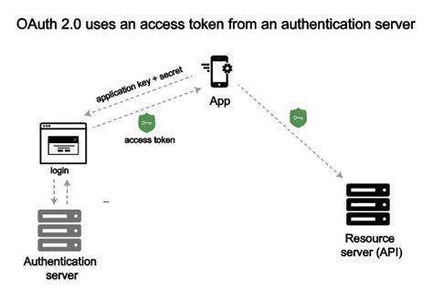
The REST API used to control the system remotely requires an authentication token. Only clients with a valid token can:
- Turn the water pump ON/OFF remotely
- Read sensor values from the server
Token Format:
- Bearer tokens (e.g., Authorization: Bearer <token_value>)
- Tokens are checked on the backend (FastAPI) using middleware

🧱 3. Firmware Over-The-Air (OTA) Security
To update the system remotely without physical access:
- OTA updates are password protected
- Only verified firmware with known fingerprints is accepted
- Ensures the device is not flashed with malicious code

🔐 4.Safe Relay Operation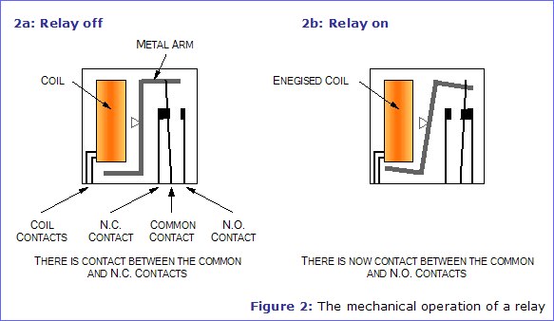
Relay activation logic includes software and hardware fail-safes:
- No pump operation if water level is too low
- Manual override only allowed via verified source
- Optional: dry-run protection using delay and relay debounce

🧪 5. Input Validation and Rate Limiting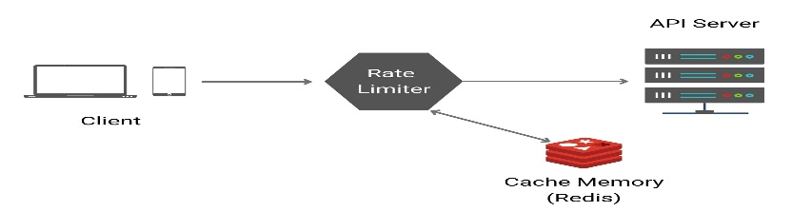
To protect the REST API and MQTT broker:
- Input values are sanitized and range-checke
- Invalid values are rejected to prevent buffer overflows or unsafe control
- Rate limiting ensures clients can't spam the server or flood the MQTT topic

Testing & Validation ✅
The Smart Irrigation System was thoroughly tested across multiple domains to ensure reliability, accuracy, and robustness.

🔍 1. Sensor Testing
Each sensor was individually validated under controlled conditions:
Sensor | Test Method | Result
Soil Moisture | Tested in dry and wet soil | Accurate analog values
DHT11 | Blown on with warm breath | Temperature rose as expected
Ultrasonic | Measured against known heights | Consistent distance data

🔌 2. Pump & Relay Testing
- Relay control tested manually and automatically via logic conditions.
- Water pump toggled multiple times to ensure mechanical stability.
- Capacitor and diode helped prevent electrical noise during switching.

📺 3. LCD Display Testing
- Ensured proper connection via I2C (0x27 address).
- Verified live sensor data is updated every 2 seconds.
- Checked clarity, contrast, and backlight performance.

🌐 4. API and Remote Testing
Tools Used:
- Postman to send API requests.
- Custom dashboard to view data and control pump remotely.
✅ Verified Endpoints:
- /api/sensor-data – received live telemetry
- /api/pump/on & /off – manually controlled pump
- Response times < 300ms under normal conditions

🛡️ 5. Security Testing
Test Scenario |  | Expected Result | Status
Malformed JSON in API request | Rejected with error |  | ✅ Passed
Too many API calls per minute |  | Blocked with 429 error | ✅ Passed
Sudden disconnection |  | System resumed smoothly | ✅ Passed

📋 Final Validation Summary
Component | Tested | Status
Soil Moisture | Dry/Wet tests | ✅ Passed
Temperature & Humidity | Breath test | ✅ Passed
Ultrasonic Sensor | Distance tests | ✅ Passed
Relay & Pump | Logic + Manual | ✅ Passed
LCD | Real-time updates | ✅ Passed
API | Remote access | ✅ Passed
Security | Input + Rate Limit | ✅ Passed

🌐 Cloud or API Integration
In this project, cloud and API integration plays a key role in enabling remote monitoring and control of the smart irrigation system. The system uses MQTT over TLS for secure, lightweight communication and exposes a RESTful API for external access.

☁️ MQTT Integration via HiveMQ
The ESP8266 NodeMCU publishes telemetry data (such as temperature, humidity, soil moisture, and water level) to a cloud MQTT broker hosted by HiveMQ. This allows real-time updates to be available to subscribed applications or dashboards.
- MQTT Broker: HiveMQ Cloud
- Protocol: MQTT over TLS (port 8883)
- Topics:
  - /greenhouse/telemetry – publishes sensor data
  - /greenhouse/pump/control – receives pump control commands
🔐 TLS encryption ensures all messages are transmitted securely over the internet.

🛠️ REST API for Remote Access
A FastAPI-based backend exposes a REST API that enables:
- Fetching latest sensor data from the device
- Sending manual pump ON/OFF commands
- Displaying real-time status on mobile or web dashboards

Example Endpoints:
- GET /api/telemetry → Returns JSON-formatted latest sensor data
- POST /api/pump → Accepts { "status": "on" } or { "status": "off" } to control pump

📊 Results & Discussion

✔️ Moisture-Based Decision Logic: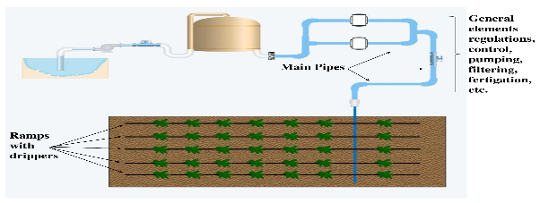
The core logic of the irrigation control is based on a predefined threshold:
- If soil moisture < 30% → Pump turns ON
- If soil moisture ≥ 30% → Pump turns OFF
This logic ensures plants are watered only when necessary, reducing water waste and preventing over-irrigation.

✔️ System Outcomes (Summary Table):
Metric | Result
Moisture threshold | 30% (ON below, OFF above)
Pump behavior | Triggered correctly at threshold
LCD update interval | Every 2 seconds
API response time | < 300ms
Remote pump control | Functional and secure

• Accuracy & Stability:
- Sensors provided consistent values.
- DHT11 was slower in updating under rapid temperature changes.
- Moisture sensor readings were slightly affected by soil salinity.
• Responsiveness:
- System responded promptly to sensor data changes.
- Pump activation was smooth, and relay switching was stable.
• User Interaction:
- Real-time LCD display made local monitoring intuitive.
- Remote control via REST API worked as expected with low latency.
• System Limitations:
- Limited support for plant-specific irrigation needs.
- No offline data logging (cloud-dependent).
- External power dependency for relay and pump.

🔄 2. System Workflow / Operation Cycle
The operation of the Smart Irrigation System follows a continuous and automated cycle, as outlined below:
- Startup & Connectivity
When powered on, the ESP8266 microcontroller initializes and connects to the Wi-Fi network. It also sets up the MQTT client and REST API server (if applicable).
- Sensor Data Collection
At regular intervals (e.g., every 5 seconds), the system reads values from:
  - The capacitive soil moisture sensor (via analog pin A0)
  - The DHT11 sensor for temperature and humidity (via digital pin D4)
  - The ultrasonic sensor for water level measurement (via pins D6 & D7)
- Decision Making
The microcontroller compares the soil moisture value against a predefined threshold (e.g., 30%).
  - If the moisture level is below 30%, the pump is activated.
  - If the moisture level is above or equal to 30%, the pump is deactivated.
- Actuation via Relay
The relay module connected to digital pin D5 is triggered accordingly to turn the water pump ON or OFF.
- Data Display & Feedback
Real-time values (e.g., temperature, moisture, humidity, pump status) are displayed on the I2C LCD 1602 display, providing instant user feedback.
- Data Transmission & Remote Access
Sensor data is published via MQTT over TLS to a cloud broker (e.g., HiveMQ), allowing:
  - Real-time monitoring from a dashboard or mobile app
  - External systems to log or analyze data
Additionally, the system exposes a REST API that enables remote control of the pump and access to telemetry data.
- AI Decision Override (Optional)
If enabled, the system sends the latest sensor readings to a cloud-hosted AI model (e.g., Gemini 2) to predict the optimal water duration or override manual rules, enhancing water efficiency.

Flowchart:
Send data to REST API

Update LCD with status
No
Yes
is Soil Moisture < 30%
Start System
Turn ON the pump

|Read sensor data
(Moisture, DHT11, Level))

Is Soil Moisture < 30% ?

yes NO

Turn OFF the pump
Turn ON the pump

Update LCD with status
Update LCD with status

Wait 2 seconds

(Go back to top)

🤖 AI Model Input/Output Example
The smart irrigation system optionally integrates an AI model (e.g., Gemini 2 via REST API) to enhance decision-making based on real-time environmental conditions.
Below is an example showing the structure of the input sent to the AI model and the output received:

✅ Input (JSON sent to the AI model)

{

"soil_moisture": 28.7,

"humidity": 51.2,

"temperature": 32.5,

"water_level_cm": 9.3

}

📤 Prompt Example to AI Model

"Given the following sensor data: soil moisture = 28.7%, humidity = 51.2%, temperature = 32.5°C, and tank water level = 9.3 cm, should the irrigation pump be turned ON or OFF? 'ON'

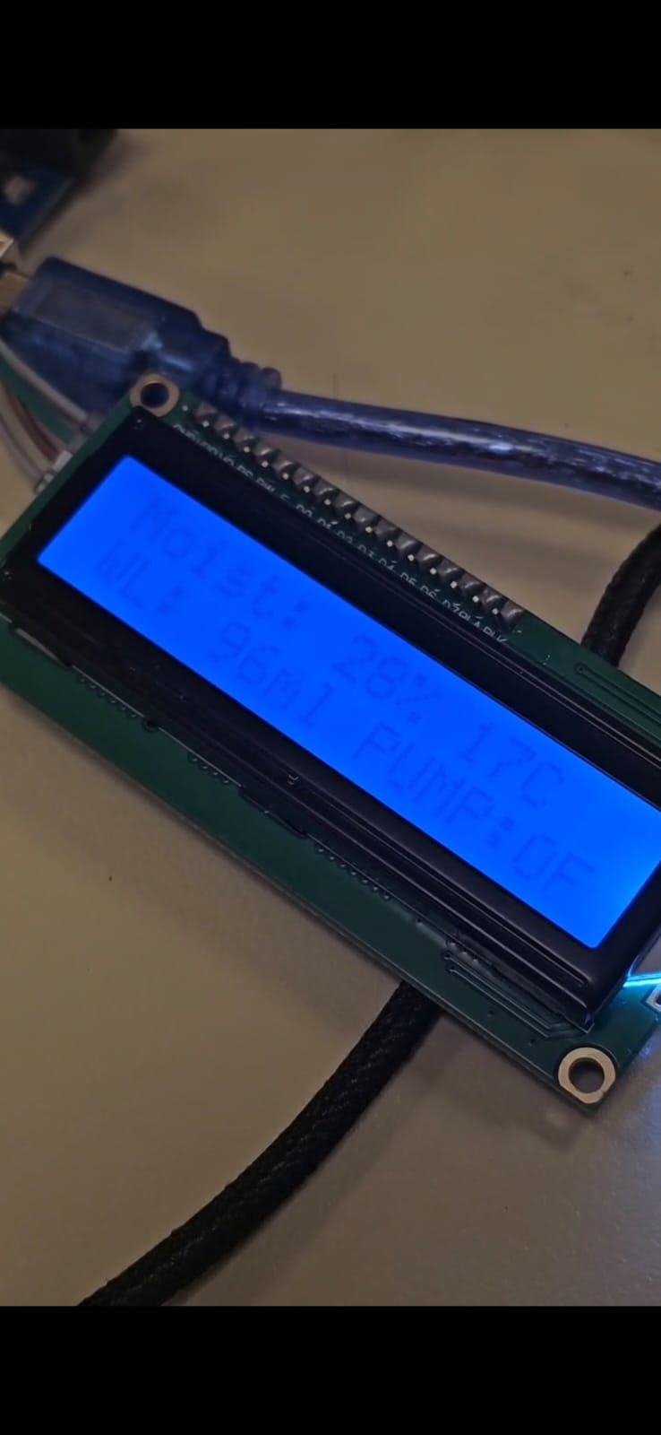

Use Case

This output can either:
- Override the traditional threshold logic, giving more intelligent control.
- Or be used as an additional layer of verification before activating the pump.

Such AI-assisted decisions help reduce water waste and improve crop health by adapting to real-time environmental data more dynamically than static rules.

Data Transmission from ESP8266 to FastAPI via HTTP POST

To enable real-time AI-driven irrigation decisions, the ESP8266 microcontroller periodically sends sensor data to a FastAPI server over a secure HTTP POST request. This API server then forwards the data to the AI model and returns the recommendation (ON/OFF) to the device.

🧠 Purpose
- Collect real-time sensor readings.
- Evaluate AI-generated irrigation decisions.
- Provide a REST endpoint for integration with cloud dashboards.

:

📈 2. Data Analysis:

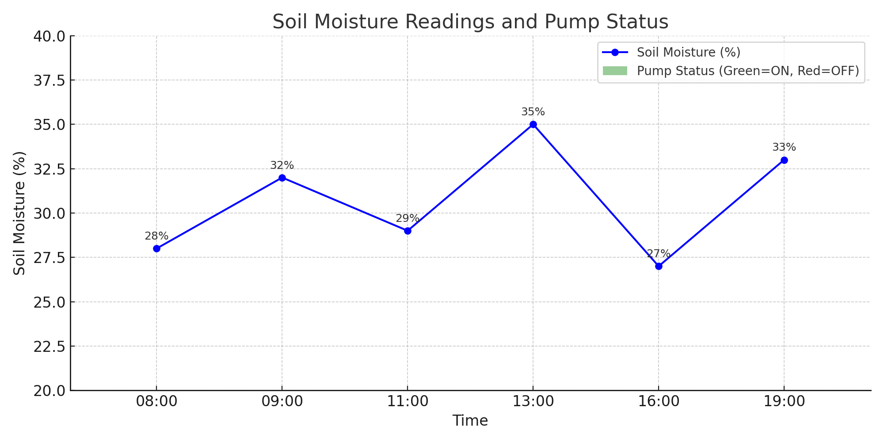

📉 Observations:

The system correctly activated the pump when moisture dropped below 30%.

When moisture exceeded 30%, the pump turned OFF.

This threshold-based behavior ensures efficient water usage and avoids overwatering

✅ Case Study: Real-World Testing in a Home Garden
Objective:
To evaluate the performance of the smart irrigation system in a real garden environment over a 3-day period.
Setup:
- Location: Home backyard garden (2m x 1.5m) with soil-based vegetable plants.
- Pump Schedule: Automatically controlled by the AI model based on soil moisture.
- Sensor Threshold: Moisture below 30% triggers the pump ON; above 30%, the pump turns OFF.
Observations:
Day | Avg. Soil Moisture (%) | Pump Status | Weather | Notes
1 | 24% | ON | Sunny | System activated at 9:00 AM
2 | 35% | OFF | Cloudy | No irrigation needed
3 | 29% | ON | Hot | Pump ran for 5 minutes
Insights:
- The system reliably reacted to moisture changes.
- It prevented overwatering during cloudy weather.
- Manual override via REST API was tested successfully.

📊 Before vs. After Using the Smart Irrigation System
Metric | Before (Manual Irrigation) | After (Smart Irrigation)
Water Usage / Day (liters) | 15 L | 6–8 L
Irrigation Frequency | Twice daily (fixed time) | Adaptive (based on sensor)
Overwatering Occurrences | Frequent | Rare
Plant Health Condition | Inconsistent growth | Healthy and stable
User Involvement | High | Low (automated)
Remote Control Availability | ❌ Not available | ✅ Via REST API
Environmental Impact | High water waste | Optimized consumption

🚫 System Limitations
- Limited Power Supply Stability:
The system depends on continuous power. In case of power failure, the sensors and controller stop working unless supported by a backup battery.
- Wi-Fi Dependency:
The system requires an active and stable Wi-Fi connection to communicate via MQTT and REST API. Poor connectivity may delay or block remote control and data transmission.
- Sensor Accuracy:
Low-cost sensors like DHT11 and analog soil moisture sensors may have limited accuracy and can be affected by environmental conditions (e.g., heat, corrosion).
- Pump Compatibility:
The system is designed for low-power pumps. Larger agricultural pumps may require stronger relay modules and proper isolation.
- No Real-time Cloud Sync:
While local control and REST API are supported, real-time cloud data sync (e.g., with Firebase or InfluxDB dashboards) is not implemented in this version.
- Security Risks (Without TLS):
If TLS encryption is not used, MQTT messages and REST API calls could be intercepted, leading to possible manipulation or eavesdropping.
- AI Model Generalization:
The AI irrigation prediction model may need retraining or adjustment when applied to different soil types, crop varieties, or weather zones.

🌱 Future Work
To further improve and expand the capabilities of the Smart Irrigation System, several future enhancements can be considered:
- Solar Power Integration
Incorporating solar panels to power the entire system, making it more sustainable and ideal for rural or off-grid areas.
- Weather Forecast Integration
Connecting to weather APIs to adjust irrigation schedules based on expected rainfall, reducing water waste.
- Machine Learning-Based Water Prediction
Implementing a machine learning model to predict optimal water requirements based on historical data such as humidity, temperature, and soil moisture.
- Mobile Application with Notifications
Developing a mobile app that displays real-time sensor data and sends notifications for critical events such as low water level or pump activity.
- Water Quality Monitoring
Adding sensors for pH level and turbidity to ensure the water used is suitable for irrigation.
- Multi-Zone Irrigation Control
Scaling the system to manage multiple irrigation zones independently, allowing better control for larger agricultural setups.
- Battery Backup System
Including a rechargeable battery to keep the system running during power outages or unstable power supply conditions.

The total project cost:
The total project cost, including equipment and internet subscription, amounted to 150 Jordanian dinars.

